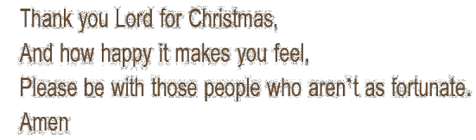
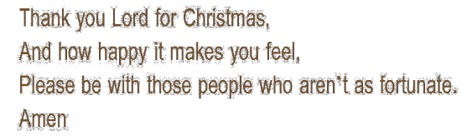
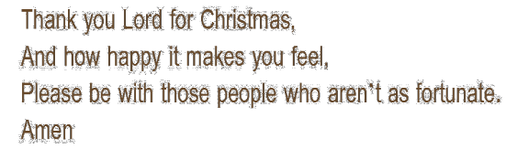

A Blessing of the Christmas Tree in the Home

When you switch on your Christmas tree lights!!

Lord our God, We praise you for the light of creation:
the sun, the moon, and the stars of the night.
We praise you for the light of Israel: The Law, the
prophets, and the wisdom of the Scriptures. We praise you for Jesus Christ, your Son: he is Emmanuel, God-with-us, the Prince of Peace, who fills us with the wonder of your love.
Lord God, Let your blessing come upon us as we light up this tree. May the light and cheer it gives us be a sign of the joy that fills our hearts. May all who delight in this share and spread this Joy. We ask this through Christ our Lord. Amen

A Blessing of the Crib in the Home
As the final figures are ready to be put into the crib!! God of every nation and people, from the very
beginning of creation you have shown us your love: When our need for a Saviour was great you sent
your Son for us. To our lives he brings joy and peace, justice, mercy, and love. Lord, Bless all who look
upon this manger, May it remind us of Jesus’ humble
birth and may it remind us to show to others the love he has shown us. Amen
A Blessing of the Christmas Tree in the Home

When you switch on your Christmas tree lights!!

Lord our God, We praise you for the light of creation:
the sun, the moon, and the stars of the night.
We praise you for the light of Israel: The Law, the
prophets, and the wisdom of the Scriptures. We praise you for Jesus Christ, your Son: he is Emmanuel, God-with-us, the Prince of Peace, who fills us with the wonder of your love.
Lord God, Let your blessing come upon us as we light up this tree. May the light and cheer it gives us be a sign of the joy that fills our hearts. May all who delight in this share and spread this Joy. We ask this through Christ our Lord. Amen

A Blessing of the Crib in the Home
As the final figures are ready to be put into the crib!! God of every nation and people, from the very
beginning of creation you have shown us your love: When our need for a Saviour was great you sent
your Son for us. To our lives he brings joy and peace, justice, mercy, and love. Lord, Bless all who look
upon this manger, May it remind us of Jesus’ humble
birth and may it remind us to show to others the love he has shown us. Amen
A Blessing of the Christmas Tree in the Home

When your switch on you Christmas tree lights!!

Lord our God, We praise you for the light of creation:
the sun, the moon, and the stars of the night.
We praise you for the light of Israel: The Law, the
prophets, and the wisdom of the Scriptures. We praise you for Jesus Christ, your Son: he is Emmanuel, God-with-us, the Prince of Peace, who fills us with the wonder of your love.
Lord God, Let your blessing come upon us as we light up this tree. May the light and cheer it gives us be a sign of the joy that fills our hearts. May all who delight in this share and spread this Joy. We ask this through Christ our Lord. Amen

A Blessing of the Crib in the Home
As the final figures are ready to be put into the crib!! God of every nation and people, from the very
beginning of creation you have shown us your love: When our need for a Saviour was great you sent
your Son for us. To our lives he brings joy and peace, justice, mercy, and love. Lord, Bless all who look
upon this manger, May it remind us of Jesus’ humble
birth and may it remind us to show to others the love he has shown us. Amen

A Prayer for those travelling home this Christmas

Loving God protect and watch over all our loved ones who are travelling home to be with us this Christmas. May they arrive safely to share this season of joy with us. We ask this in your care. Amen

A Family Prayer before the Christmas Meal

Loving God, on this Christmas day we give thanks that Jesus, your Son, has come into our world bringing us gifts of peace and joy. Bless us as we sit down together at this table
for our Christmas meal. Bless the food we share and help us to remember those who are hungry. Be with our neighbours and our friends, those who are lonely, sick or away from home.
We pray that our departed loved ones may now sit at your table in heaven. May the joy of this feast give us strength and light, now and in the days ahead.
We ask this prayer through Christ, Our Lord. Amen

A Family Prayer
God, this Christmas, bless our family and all its members and friends; bind us together by your love.
Give us kindness and patience to support each other; and
wisdom in all we do.
Let the gift of your peace come into our hearts and remain with us. May we always be aware of and rejoice in the blessings you have given us. Amen.
A Prayer for those travelling home this Christmas

Loving God protect and watch over all our loved ones who are travelling home to be with us this Christmas. May they arrive safely to share this season of joy with us. We ask this in your care. Amen

A Family Prayer before the Christmas Meal

Loving God, on this Christmas day we give thanks that Jesus, your Son, has come into our world bringing us gifts of peace and joy. Bless us as we sit down together at this table
for our Christmas meal. Bless the food we share and help us to remember those who are hungry. Be with our neighbours and our friends, those who are lonely, sick or away from home.
We pray that our departed loved ones may now sit at your table in heaven. May the joy of this feast give us strength and light, now and in the days ahead.
We ask this prayer through Christ, Our Lord. Amen

A Family Prayer
God, this Christmas, bless our family and all its members and friends; bind us together by your love.
Give us kindness and patience to support each other; and
wisdom in all we do.
Let the gift of your peace come into our hearts and remain with us. May we always be aware of and rejoice in the blessings you have given us. Amen.
A Prayer for those travelling home this Christmas

Loving God protect and watch over all our loved ones who are travelling home to be with us this Christmas. May they arrive safely to share this season of joy with us. We ask this in your care. Amen

A Family Prayer before the Christmas Meal

Loving God, on this Christmas day we give thanks that Jesus, your Son, has come into our world bringing us gifts of peace and joy. Bless us as we sit down together at this table
for our Christmas meal. Bless the food we share and help us to remember those who are hungry. Be with our neighbours and our friends, those who are lonely, sick or away from home.
We pray that our departed loved ones may now sit at your table in heaven. May the joy of this feast give us strength and light, now and in the days ahead.
We ask this prayer through Christ, Our Lord. Amen

A Family Prayer
God, this Christmas, bless our family and all its members and friends; bind us together by your love.
Give us kindness and patience to support each other; and
wisdom in all we do.
Let the gift of your peace come into our hearts and remain with us. May we always be aware of and rejoice in the blessings you have given us. Amen.

From all at School
From all at School
From all at School

